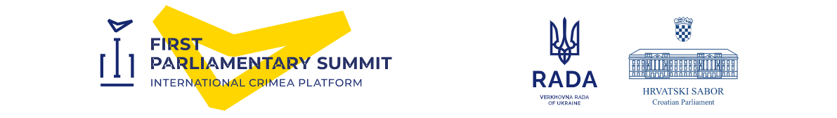

First Parliamentary Summit

of the International Crimea Platform

Zagreb, 24 - 25 October 2022

MEDIA ADVISORY

The First Parliamentary Summit of the International Crimea Platform, this year’s largest in-person gathering of speakers of parliaments, will take place on 25 October 2022 at the National and University Library building in Zagreb, Croatia.
The summit will be preceded by a welcome dinner on 24 October 2022 at The Westin Zagreb hotel.
Many speakers of parliaments representing the signees of the International Crimea Platform as well as other speakers from around the world (an estimated number of 50 delegations) are expected to participate in the first physical large-scale parliamentary summit since the beginning of the COVID pandemic.
Due to the highly demanding security situation and unsafe conditions in Ukraine, the Parliament of the Republic of Croatia (Croatian Sabor) accepted the request of the Ukrainian parliament (Verkhovna Rada), to host the First Parliamentary Summit of the International Crimea Platform in Zagreb.
Organized jointly by the Croatian Sabor and Verkhovna Rada, this parliamentary dimension follows the inaugural and second online International Crimea Platform Summit held in August 2022.
The opening of the summit on 25 October 2022 will include remarks from Croatian speaker Gordan Jandroković, Ukrainian speaker Ruslan Stefanchuk and Croatian prime minister Andrej Plenković. The President of Ukraine Volodymyr Zelenskyy will address the summit via video-link at the opening of the summit. A detailed program will be available shortly on the website of the Croatian Parliament and sent to the accredited media representatives directly.

Practical information for media

- Media Accreditation
Media representatives covering the Summit must complete their accreditation request via the accreditation form by 20 October 2022 the latest. To allow sufficient time for a standard-level security clearance, we invite you to complete your accreditation well in advance. The accreditation form can be found here: (English language); (Croatian language).
Accreditation badges will be available as of 24 October 2022 from 4:00 p.m. to 7:30 p.m. at The Westin Zagreb hotel (address: Ulica Izidora Kršnjavoga 1) and on 25 October 2022 from 7:30 a.m. to 9:30 a.m. at the Eastern PRESS entrance to the summit building.

- Photo and video opportunities
- 24 October 2022 (approx. 8:00 p.m.): beginning of the welcome dinner at The Westin Zagreb hotel (limited time set);
- 25 October 2022 (8:30 – 9:20 a.m.): doorstep arrivals of the heads of delegations in the entrance hall of the National and University Library and welcome greetings by the hosts, the Speaker of the Parliament of Croatia, Mr. Jandroković, and the Speaker of the Verkhovna Rada of Ukraine, Mr. Stefanchuk;
- 25 October 2022 (9:25 a.m.): the family photo in the entrance hall of the National and University Library;
- 25 October 2022 (9:30 a.m.): beginning of the summit (limited time set);
- 25 October 2022 (approx. 1:45 p.m.): press statements given by Croatian and Ukrainian speakers Gordan Jandroković and Ruslan Stefanchuk;

- Video pool
The summit host broadcaster is the Croatian Radio and Television (HRT). HRT will ensure the AV signal (EBU standard) from the summit session room “Dora”. For further information on the coverage of the event and signal requests, as well as satellite parameters in advance, please contact: mediadesk@hrt.hr

- Photo pool
The photo agency (FaH) of the Croatian news agency (HINA) will cover the summit session room “Dora”. Contact: fah@hina.hr

- Press statements
The Speaker of the Croatian Parliament Gordan Jandroković and the Speaker of Verkhovna Rada of Ukraine Ruslan Stefanchuk will give press statements after the session (on-location updates by the Press Office of the Croatian Parliament).

- Press entrance
Media will be admitted to the summit building at the Eastern PRESS entrance.

- Press room
Media will be located in the Press Room “Judita” and provided with live-streams in English, Croatian and Ukrainian.

- OB vans on-site
For positions, please contact: press.crimea.zagreb@sabor.hr

- Broadcasting requirements
Additional broadcasting requirements, like registration for and allocation of stand-up positions, should be notified to the host broadcaster (HRT) and will incur charges. For queries and bookings, please contact the host broadcaster directly:
international@hrt.hr; phone: + 385 99 634 3681.

- Information updates
Media will be informed on any updates on location and via web (English language); (Croatian language).

- Contacts

Marina Buntić Juričić (accreditation, inquiries, general info)
e-mail press.crimea.zagreb@sabor.hr; mobile +385/99/8154-634

Sandra Rizmaul (spokesperson of Mr. Jandroković)
e-mail sandra.rizmaul@sabor.hr; mobile +385/99/5217-371

Kateryna Lysenko (spokesperson of Mr. Stefanchuk)
e-mail katya.lyusenko@gmail.com; mobile +380/980795609

